Livia Armstrong
Dr. Gomaa
Literature of Place
27 June 2024
Wandering Through Oxford: Insights and Impressions
While looking for colleges, one of my main requirements was that the school had a study abroad program. Traveling the world is a lifetime goal of mine. Over the course of my life, I plan to see as much of the world as possible because I believe that I can learn so much from every culture and person I encounter. Not to mention, the world is beautiful. Unfortunately, the demands of my majors did not permit me to study abroad for the duration of a semester, so, I took up the next best option. Oxford seemed like the perfect place to begin my traveling journey, and luckily, my assumption was correct. The lack of a language barrier made the adjustment much simpler and less stressful than I assumed it would be with one. Part of me truly enjoyed taking some time to myself and exploring the city on my own, but I also relished in the time I spent with my new friends. Each day, I discovered new aspects of Oxford, my friends, and myself, making this the trip I had desired it to be. This trip has convinced me that I am doing the right things for myself. I am making the right decisions and plans at the right times and from now on, I am not looking back. Renowned for its historical beauty and rich cultural heritage, this place has provided me with an unparalleled backdrop for intellectual growth and self-discovery. From navigating the rigorous academic workload to immersing myself in the vibrant local culture, studying abroad in Oxford has broadened my horizons, challenged my preconceptions, and fostered a deeper understanding of both myself, and the world around me.

Observation, and Where I Fit In
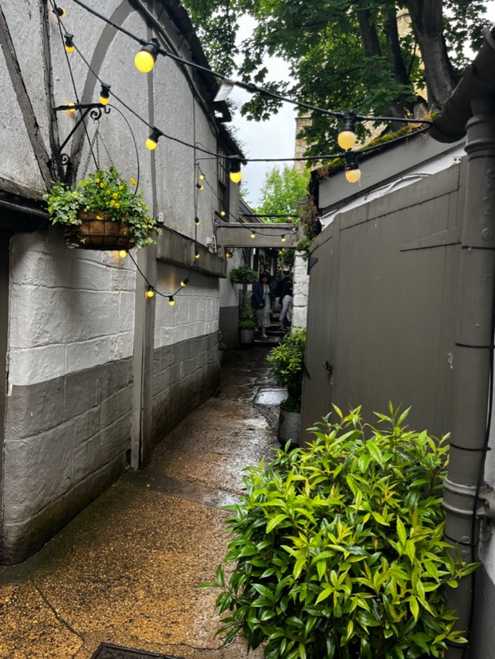
Dine and See
One place that I visited frequently throughout my stay in Oxford is a uniquely designed, historical, and lively pub called turf tavern. I found this spot to be quite interesting, not only for its exciting social vibe, but also for its historical significance that made me feel closer to Oxford’s origins. While reading a little information about the tavern, my parents and I discovered that being one of the oldest pubs in Oxford, it dates back all the way to the 12th century. Walking through the pub, something that stood out to me was how much seating there was, both inside and outside. I especially admire the way they decorated and designed the rooms. It created a certain ambiance that allowed for a relaxed, yet fun time. In one of the rooms, where the main bar is situated, I could hardly stand up all the way because the ceiling was so low. I also noticed that the floor was quite uneven and was basically slanted. That is when I realized that this specific section of the pub was the original one that dates back to so long ago. Of course, there has had to have been some renovation over the years, but it still felt quite interesting to be in a place that felt so old and meaningful. I also found it interesting that it is situated snug up against the original city wall, which still has ports from which archers would stand to defend the city. Out of all the pubs I visited in Oxford, this one must be my favorite.
A walkway leading up to the seating area in Turf Tavern.

Chaining History to a Shelf
This is the portion of the Bodleian Library that we had the pleasure of walking through. There were two levels of shelves that obtained about 14,000 books.

Visiting the Bodleian Library was one of the highlights of my experience in Oxford. As someone who typically does not enjoy learning history or studying literature, I was surprised to have had quite the pleasant experience. As we walked up the stairs, it was very interesting to learn that it is still used as a functioning library for university students, but also serves as this sort of historical visitation center. With it being the oldest library in Europe, I am sure it is quite the attraction for tourists and the people residing in Oxford. With over 14,000 books in just that one small section of the library, it is astonishing to think about all the information that lives inside that building. The way that Thomas Bodley designed the library seemed to be so well-thought out, with the ways the books were organized, as well as how to work around the issues that came with chaining the books to the shelves. I admired the way that our tour guide was able to really put into perspective just how intricate and specific every detail of the library had to be. To be in a place so full of history, that is so untouched and cherished deeply, is quite utterly an honor.
Observe and Learn Fruitfully
Anne Elliot, in Jane Austen’s Persuasion, is characterized by her acute abilities of observation and sensitivity to the feelings and behaviors of those around her. This trait is evident in her ability to read and understand people’s emotions and motivations. A clear example of her observant nature is reflected when Austen states, “Anne, with an elegance of mind and sweetness of character, which must have placed her high with any people of real understanding, was nobody with either father or sister; her word had no weight…” (5). This passage highlights Anne’s acute awareness of her own position within her family and society. She understands the vanity of her father and sister and recognizes her own undervalued status among them. Anne’s ability to see through what is on display and comprehend the true nature of their character showcases her perceptive and observant nature. Like Anne, I find myself to be able to see past the façade that many people in society put forward. Throughout my life, I have been told that I tend to have a mature perspective on situations, and I find that it is due to my ability to “read” people. Typically, I can see the way a person is feeling before they express it, which therefore allows me to act in accordance with what the person needs or what I need from that person. Being observant has had a positive impact on my social life, and I believe that it did the same for Anne throughout her journey of growth and self-discovery.

Change of Scenery, Change of Self
“It’s Just a Pile of Rocks”

On one of our weekend trips, we visited one of the wonders of the world, Stonehenge. Located amongst endless fields with cows, crops, and historical sites, it is situated within a beautiful landscape in Wiltshire. Leading up to our visit, many people warned me that it would be underwhelming and to lower my expectations, but I was quite honestly amazed. As a prehistoric monument, it invited me to contemplate about the people who built it and their reasons, whether for ceremonial, astronomical, or other unknown purposes. Built 4,500 years ago, the stones have withstood more time than I find believable. The alignment of the stones with the solstices highlighted the ancient understanding of the cosmos which was quite awe-inspiring. Walking around the monument, I felt a deep appreciation for the historical significance and the enduring mystery of Stonehenge, leaving me with a sense of wonder and curiosity about our ancestors’ capabilities and intentions. This visit not only enriched my knowledge of ancient history but also fostered a deeper connection to the timeless quest for meaning and understanding.
The Stonehenge rock formation situated in Salisbury.
Surround Sound: Letting Music Fill My Soul
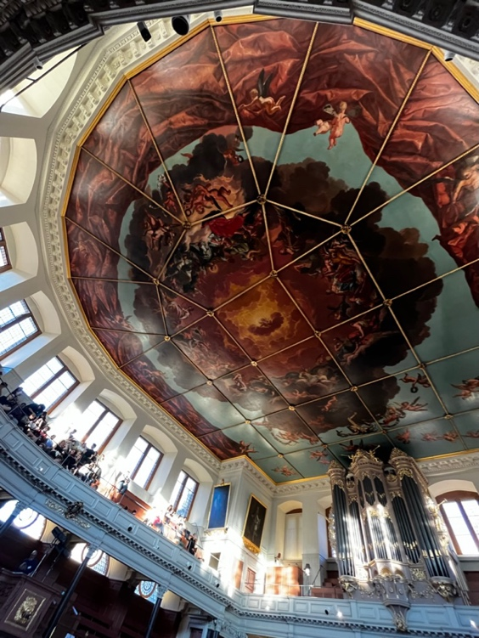
As a dancer, I tend to have a deep connection with music. When I hear music, my brain goes through processes of sorting the rhythms, identifying the feel, and visualizing what story could match the movement of the music. Naturally, I often move my body unconsciously, either by tapping my foot, or swaying from side to side. Sometimes, I even find myself subtly moving in whatever choreography the music sparks in my head. In many of my dance classes at school, we focus on ‘deep listening’, which typically consists of closing our eyes, feeling the pulse of the music, moving in the direction the music pulls us, and identifying every layer present in the song. For those who have never tried or do not understand basic dance structure, it is very difficult to explain exactly the way the music consumes me. At the Oxford Millennium Orchestra concert, I had a similar sensation as I do when I ‘deep listen’, but this was an even more intense consumption. For the duration of the concert, I was engulfed in the waves of sound pouring through my ears and into my mind. There was this sort of moving and emotional feel to the music that went above and beyond my expectations. At one point, there was this surge in the energy of the music just as the light started shining brightly through the windows, filling the room up with exuberance and peace. Time stopped. Everything in the world paused, for just that moment. In the room, there was only light and sound. I would describe it almost as a heavenly experience. What is so special about that moment to me is how I will never get it back. I can now appreciate it for what it was and how it made me feel, but that moment only existed once, and I was lucky enough to experience it.
The ceiling of the Sheldonian Theater where the Oxford Millennium Orchestra.
Embracing the Assertive: The Journey to Independence
In Jane Austen's novel Persuasion, the reader witnesses Anne Elliot's personal growth and development as she learns more about herself and steps away from her family's judgmental attitudes. Throughout the narrative, Anne overcomes her lack of independence and assertiveness. Personally, I feel that everyone is a product of the environment in which they grow up, and in Anne's case, no one taught her to be assertive and speak up for what she wants. The new freedom that came along with being separated from her family allows Anne to become surer of herself and happier with her own choices. For example, near the end of the story, while in Bath, she pays a visit to an old friend who has suffered financially since the death of her late husband, Mr. Smith. Anne's family criticize her for her decision to visit Mrs. Smith instead of joining them at a more prestigious dinner. Austen states, “Anne kept her appointment; the others kept theirs, and of course she heard the next morning that they had had a delightful evening” (112). Instead of giving in to her wishes and agreeing to join her family, as she had done in most previous situations, she maintained her independence and went, nonetheless. Prior to attending college, I was heavily reliant on my family and their ideals, much like Anne. I often did not feel the need to have my own opinion and would make decisions based on what would make my family happy. After spending time apart from my family, I realized how important it is for me to be my own biggest advocate. The only way I can truly have what I want and thrive in this life is if I stand up for myself and go out there and get it, just like Anne did.

Rooted in Reality: Contextual Learning
A Mystical Tour
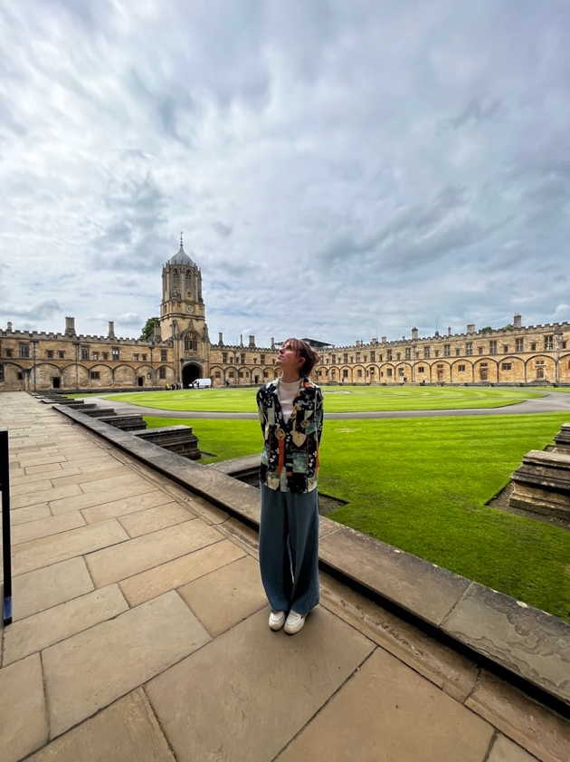
The tour of Christ Church College was one of my favorite visits in Oxford. In my opinion, Christ church seems to be the heart of Oxford, not in location, but in feel. What I mean by that is I felt this sort of historic connection to the space, and I think it is because students still live and attend school there. Knowing that students are currently attending allows me to more clearly envision how students originally went throughout their days there. I admired the ways that they have preserved the architecture and natural beauty that the college is filled with, both inside and outdoors. The dining hall particularly stood out to me because at first, it looked awfully familiar. Once I discovered that the Harry Potter movies made their dining hall based off the one at Christ Church College, it made sense. There is something to be said about being at a place that looks exactly like a movie that I have watched. This trip, in general, felt unreal and this notion supported that feeling immensely. Additionally, I appreciated the connections we had the ability to make between reading Alice in Wonderland, learning about the background of Lewis Carroll, and visiting the residence for which he resided. This experience put background to such a timepiece in American and English culture.
This is me standing in front of the quad located in the center of Christ Church College.
Living Like the Elliots

Our trip to Bath was fulfilling, exciting, and beautiful, so much so that it made me want to return. Despite loving every second of my time in Bath, one specific activity stuck out to me. The Persuasion walking tour provided me with much greater insight into the novel and allowed me to visualize what it would be like to have lived like Anne Elliot and the rest of the characters. I have never known myself to be very passionate about reading, but Persuasion kept me intrigued, and left me wanting more. Because I did not watch any of the movies, I did not have a previous notion of what the characters would look like, how they lived, or what the setting looked like. So, from the perspective of a reader, seeing Bath was a grand opportunity. Through the use of my imagination, I could see the scenes in the book playing out right in front of me, especially when there were passages from the text read aloud. It was as if I was in a dream, imagining the characters interacting in the exact place, as it was explained in the book. Because it was the first time I was excited by a book, I was invested in this tour and learning about Jane Austen. To be able to get inside her mind and see what inspired her was a gift in and of itself.
The Gravel walk where Anne Elliot and Captain Wentworth profess their love for each other in Persuasion.
Resilience in the Face of Adversity
In the novel Girl, Woman, Other by Bernadine Evaristo, the theme of resilience is portrayed through the characters’ perseverance in the face of adversity. Each woman, in each of their stories, confronts significant challenges, whether related to race, gender, or personal circumstances, yet they continue to strive for better futures. In Amma’s chapter, the author is describing the hardships Amma and many of her theatre friends have endured. The theater industry had been discriminating against them for various reasons in many different ways so they decided to create their own company when stating, “black and Asian women’s stories would get out there… they would create theatre on their own terms… it became the company’s motto… On Our Own Terms… or Not At All” (14). This quote displays the resilience present in Amma’s demeanor. Growing up as a woman, surrounded by women, I have witnessed resilience as a through-line in many of my friends’ and family’s stories. They rise above when the world either expects them to fail or does everything to cause them to fail. Encountering so many new friendships on this trip granted me the ability to hear even more women’s stories and hear how they have gotten to where they are now. Above everything else, observing their resilience has been inspiring. From their experiences, and from my own, I have learned how to stand up for myself, be proud of my own accomplishments, and go for everything I desire, no matter what anyone else has to say about it.

My experience studying in Oxford has been nothing short of transformative, combining academic rigor with personal exploration and growth. Despite not being able to participate in a full semester abroad, this journey has provided me with invaluable insights and memories that will last a lifetime. The seamless blend of history, culture, and modernity in Oxford allowed me to immerse myself fully in both my studies and the local environment. Whether it was visiting historical landmarks like the Bodleian Library and Christ Church College or enjoying the social atmosphere of Turf Tavern, every moment added depth to my understanding of the world and my place in it. The encounters with new friends, the rich history of the places I visited, and the profound moments of self-reflection have all contributed to a more nuanced perspective of who I am and who I aspire to be. This trip has reaffirmed my belief in the importance of stepping out of my comfort zone and embracing new experiences with an open mind and heart. Just as Anne Elliot from Austen’s Persuasion found strength and independence through her journey, I too have discovered a newfound sense of confidence and direction. As I move forward, I am committed to carrying the lessons and experiences from Oxford with me. I am confident that I am on the right path, making decisions that align with my goals and values. This journey has been a pivotal chapter in my life, one that has not only enriched my academic pursuits but also fostered a deeper connection to the global community. With a renewed sense of purpose and an unwavering commitment to my aspirations, I look forward to the many adventures and learning opportunities that lie ahead.

